**Data Extraction –**

1. **Uploading files to the Lakehouse**

1. **Reading Json file into table using pipeline copy activity**

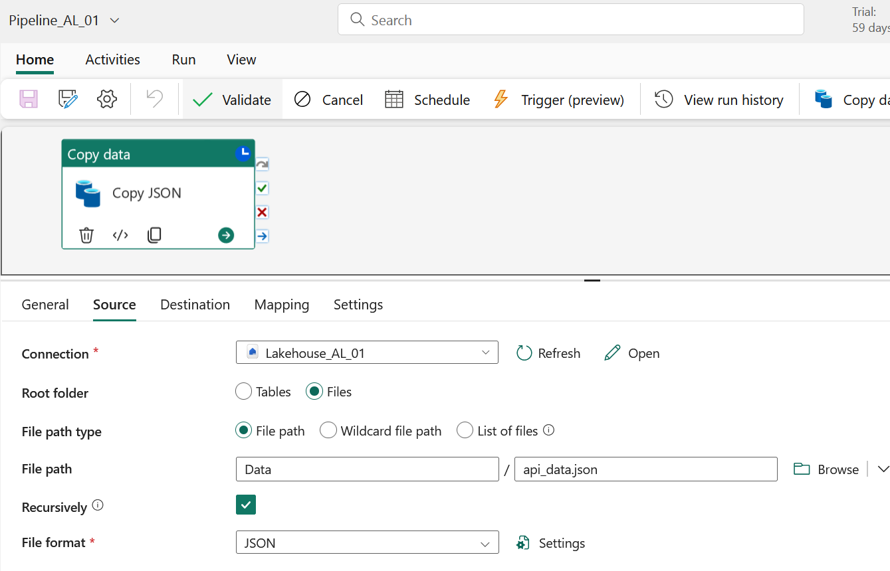

1. **Loading data from csv files into the table directly.**

